Physiotherapy Pre-Assessment

Name:
DOB:
Address:
Email:
Mobile:
Important Information:
As part of Covid precautions we were obliged to ask all new patients to complete a pre-assessment form. The aim was to reduce the time that client needed to spend in the clinic room. It has proved successful and has allowed therapists more time to treat patients.
We ask that you complete and return this form before your initial appointment.
COVID: We continue to take precautions in clinic. We ask that all patients wear a mask when in the clinic and use the hand sanitiser provided.
On arrive please ring the doorbell and wait outside, either in the large corridor by the library or under the covered entrance. During the consultation the therapist will wear appropriate PPE.
The appointments are for a maximum of 30 minutes, you will be required to leave the room promptly at this point – we must allow time between clients to properly sanitise the room between patients.
By returning this form you agree to comply with our continuing Covid precautions.

BODY CHART: Please draw on diagram if possible. Otherwise please list your symptoms.
Please draw where your symptoms and label whether it is pain, pins and needles or numbness. Please label area 1,2,3 etc
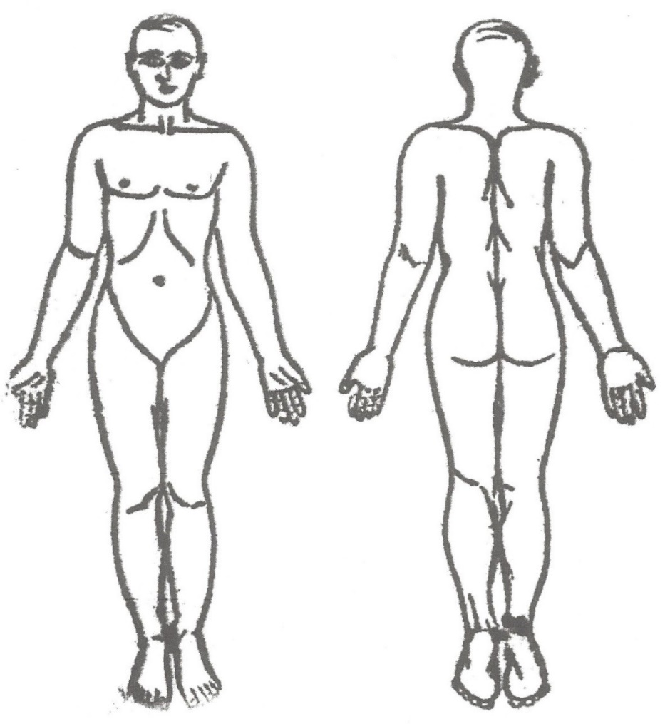
History of Presenting Condition:
- When did it start?
- What caused the problem to flare up?
- Is this the first episode, if not how many previous episode, how frequently, and when was the last episode?

- Are the symptoms linked (do symptoms 1,2,3 etc) occur together? If so is there a sequence (e.g. 2 only follows when 1 is severe)?

- What aggravates the symptoms (trying to be as specific as possible)?

- Can you do anything to ease the symptoms (i.e. heat, rest in a certain position, walk, gentle movement)?

Behaviour of Symptoms:
- Is there a pattern to your symptoms during the day?
  - Is there increased pain on waking pain before you move?
  - On getting up in morning does the pain flare up?
  - And are the symptomatic areas very stiff? If so, does that improve as you move, and how long does it take to improve?

  - Is sleep disturbed by pain at night?
  - If yes can you settle again easily?
  - What do you do to try to go back to sleep?

Previous Medical History:
- Please list any other current health issues.

- Please list any previous serious health issues (cancers, neurological conditions, surgery etc).

DRUG History:
- Please list all your current prescribed medication.

Drug History Continued:
- Please list all self-prescribed medication (paracetamol etc) and how often you take it.

Social History:
- What type of work do you do? (if it is physical please expand on what is physically required)

- Hobbies/Sports you regularly participate in.

- Please list any other regular task that you are involved with (e.g. carer)

Special Questions:
- Do you suffer from any of the following (please circle those that apply)?
Thyroid Heart Rheumatology Epilepsy Asthma Diabetes
- Have you ever had to take a course of steroids? If so how long was the course and how frequently?

- Have you had any unexplained weight loss recently?

If you have back and/or leg pain:
- Have you got any Pins & Needles or Numbness in the area that would sit on a bike saddle?

- When walking up steps do you catch your foot regularly, or do you trip and stumble frequently when walking?

- When you have the urge to empty your bladder can you manage to empty?

- Have your bowel habits changed? (What is different?)

If you have neck or head pains do you have any of the following:
- Dizziness when turning your head
- Double vision or recently altered vision
- Difficulty swallowing
- Difficulty find the right word when talking
- Unexplained fainting (drop attacks)

Outcome messages/Patient Specific Functional Scores:
Please list 3 tasks that you would usually do in a week, then rate how easy it is to complete each? Please be as specific as possible.
100% is able to perform normally without restriction and discomfort, 0% is you could not attempt the activity even if your life depended on it. The percentage score is your impression of how much the symptoms are affecting your live.
EXAMPLES:
Walk to paper shop and back. 30% (30% could mean you can do, but perhaps only alternate days or you have to rest several times there and back)
Hoover the stairs 10% (10% possibly means you could do it but only if your live depended on it!)
Load dishwasher 60% (60% can manage it without stopping but there is significant painful)
Please list 3 tasks that you are not able to complete as easily as normal and then score your ability

Please return to Paul by email paul@southamphysio.com or you can message photos of your form via WhatsApp to 07941 856 156

